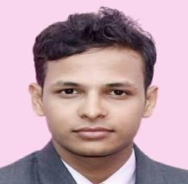
Bishesh Dhakal
Lalitpur, Nepal
+9779845555758
Email: Bishesh.dhakal11@gmail.com

PERSONAL INFORMATION
- Date of Birth : 19/01/1996
- Nationality : Nepali
- Language : English, Nepali

ACADEMIC QUALIFICATION
▪ School Leaving Certificate | : Shree Adarsha Secondary School, Birgunj
▪ Intermediate | : ST. Xavier’s School, Jawalakhel
▪ Bachelor in Civil Engineering | : Khwopa College of Engineering, Bhaktapur
ACADEMICAL EXPERIENCES

- Civil Sub-overseer instructor at Mahalaxmi School, Lubhu.
- Presented research works in 2nd international MoChWo Conference, International Conference on Earthquake Engineering and Post recovery disaster reconstruction planning.
- Research works entitled ‘Risk Assessment of Unreinforced brick masonry buildings at Bhaktapur, Nepal’ published in NEA Technical Journal 2018
- Completed multiple Online Courses on Coursera including Fundaments of GIS, quantitative research methodology, publishing scientific research papers.
- Worked as a Researcher in Center for risk, recovery & Resilience (2017)

OTHER QUALIFICATION & ACHIEVEMENTS

- Recipient of Moti-Tamang Memorial Social Service Award, ST. Xavier’s School (2013)
- Past Executive head and board member in many social organizations like Rotary Interact
Alumni Association of south Asia, Uniting Youths Nepal, Interact club of St. Xavier’s, Interact District Council: Nepal & Bhutan
- Provided leadership training and motivational classes to various age groups, mainly youth.
- Special classes attended of Memory power technique, meditation courses of Art of Living

DECLARATION
I solemnly state that all the information provided above is correct best to my knowledge and belief.

